Telephone: (675) 321-2466
(675) 320-1988
Facsimile: (675) 321-7548
(675) 320-1989

5th Flr, Defens Haus,
Cnr Champion Pde & Hunter St,
Port Moresby, NCD

PO Box 1829, Port Moresby
PAPUA NEW GUINEA

4th March 2019

Re: Doing Business in PNG and Tax Facts

- Introduction of the country and general environment of doing business
Papua New Guinea (PNG) is an Oceanian country that occupies the eastern half of the island of New Guinea. PNG established its sovereignty in 1975 followed nearly 60 years of Australian administration which started during World War. It has been an independent Commonwealth realm since 1975 with Elizabeth II as its queen. PNG has 852 known languages but official languages are English and Tok Pisin. PNG has population of 7.9 million and land area is 452,860 square km.

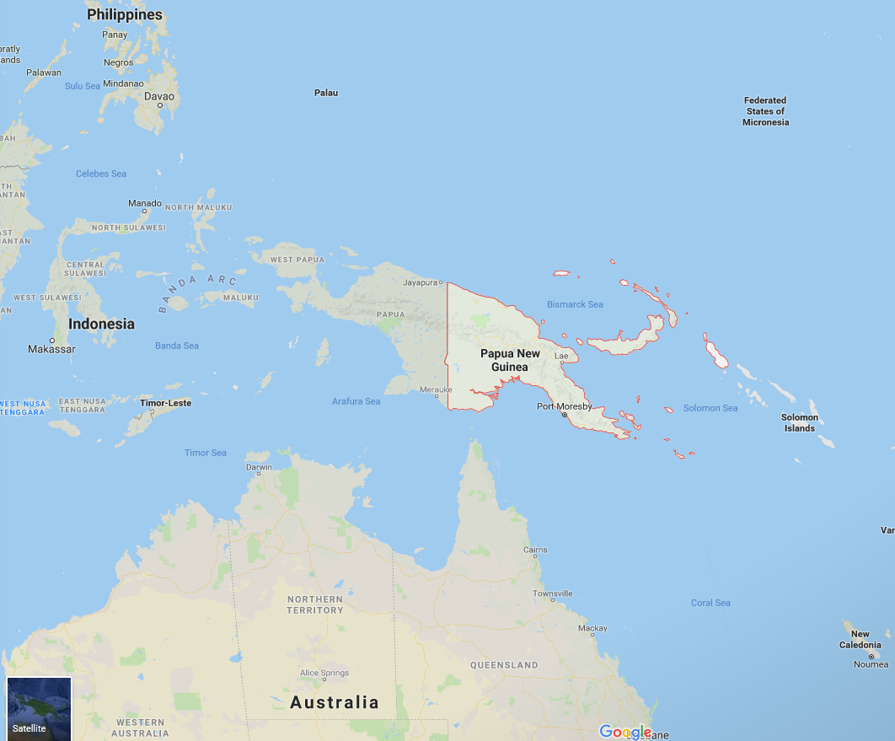

PNG is rich in natural resources and tropical agricultural products including mineral, forests, fishery, palm oil, coco, coffee bean, natural gas and oil. Papua New Guinea has recorded high levels of economic growth for a number of years, mainly on the back of the PNG liquefied natural gas (LNG) project, which began production in mid-2014. Economic growth slowed down significantly since 2015 due to weak demand in agricultural products, timber, minerals, oil and gas.

Currently PNG’s imports are around A$3.9 billion and exports are around A$ 2.2 billion.

PNG has a ‘wantok system’. Business people like to see the same face representing a company on successive visits. Business laws are based on English legal principles, but application is less rigorous.

Security concerns and government corruption are main threats for doing business in PNG.

In addition, PNG has foreign exchange control in place. The Bank of Papua New Guinea imposes restriction on opening offshore bank accounts, licensing gold exports, licensing foreign exchange dealers and removing cash in excess of PGK 20,000. Repatriation payments can be made in any foreign currency. However, if the remittance exceeds PGK 500,000 or cumulative amounts of PGK 500,000 per fiscal year by a resident taxpayer, a tax clearance certificate must be obtained from the Internal Revenue Commission (IRC) before the remittance is made.

- Start up a business
In PNG you can operate as follows:

- Establish a PNG registered company (resident company or subsidiary) – Tax rate 30%.
- Register as a Non-resident / overseas company (branch operation) – Tax rate 48%
- Operate either fully or partially within PNG as a foreign contractor – Tax rate of 15% on the gross revenue.
Relevant Acts for regulations:
- Companies Act Requirements - Where a company incorporated outside PNG commences to carry on business in PNG it is required within one month of commencement to register as an overseas company under the Companies Act. For the purposes of the Companies Act the term “carrying on business” is given an extended meaning but otherwise has its ordinary meaning. As a general proposition, an overseas company that enters into a contract for work to be done in PNG and undertakes work in the country for a period of more than 30 days would be regarded as carrying on business in PNG for the purposes of the Companies Act.

- Investment Promotion Act - Companies with foreign shareholdings of 50% or more (held or controlled by non-citizens of PNG) are required to be certified by the Investment Promotion Authority (IPA) before they can carry on business in PNG. The meaning of carrying on business for the purposes of the Investment Promotion Act, so far as is relevant, is identical to the meaning of carrying on business for the purposes of the Companies Act. It follows that this requirement applies whether an overseas company intends to carry on business in PNG through a subsidiary or through a branch.

3. Tax overview
PNG’s tax regime is based on the Income Tax Act, the Goods and Services Tax Act, the Customs Act and the Excise Tax Act, and supported by related legislation and regulations.
- Income Tax for Individual:
Financial period

The standard financial period, or year of income, is the 12 month period ending 31 December.

Personal income tax rates 2019

Income earned by individuals is taxed at marginal rates. The rates which apply to resident individuals differ from those which apply to non-resident individuals.

From 1 January 2019 the tax rates for individuals who are residents of PNG are as follows:

Income K | Marginal Tax Rate %
1 – 12,500 | 0
12,501 – 20,000 | 22
20,001 – 33,000 | 30
33,001 – 70,000 | 35
70,001 – 250,000 | 40
250,000 + | 42

From 1 January 2019 the tax rates for individuals who are non-residents of PNG are as follows:

Taxable Income K | Marginal Tax Rate %
1 – 20,000 | 22
20,001 – 33,000 | 30
33,001 – 70,000 | 35
70,001 – 250,000 | 40
250,000 + | 42

Fringe benefits

Benefits provided to employees are taxed at the prescribed values listed below:

Benefit | Taxable value per fortnight
Accommodation owned or rented by employer within PNG | Nil to K2,500 per fortnight depending on area, market value or market rental per week
Mess / Barracks | Nil to K60 per fortnight depending on area
Government Mess / Barracks | Nil to K7 per fortnight depending on area
Housing allowance | The employee will be taxed on the excess of housing allowance over eligible housing expenditure and on the prescribed value of the housing. A PNG citizen who receives an allowance under a Citizen Employee First Time Home Buyer Scheme is not subject to tax on the allowance.
Motor vehicle | Vehicle and fuel provided by employer: K125 per fortnight. Vehicle only provided: K95 per fortnight
Education expenses (except tertiary education) | Nil
Leave fares | One annual fare for the employee and his/her family to the place of recruitment or origin is exempt from tax. Alternatively, recreational fares and accommodation for travel within PNG to the value of the benefit of one annual leave fare are exempt from tax.  Additional leave fares are fully taxable, however additional leave fares within PNG for a person employed solely in, or in connection with most resource projects are exempt. Additional leave fares for employees serving in hardship or remote  areas may be exempted from tax at the discretion of the IRC.
Contribution by employer to an authorised or overseas superannuation fund | Nil. However, an employer is not entitled to a tax deduction for contributions made to an overseas fund.
Meals | Messing type meals: K30 per fortnight. All other meals are subject to tax on the amount equal to the employer’s cost.
Public utilities, gas, domestic services, security, club subscriptions | If paid by the employer on domestic services, on behalf of the employee, it is not taxable to the employee, however the employer is denied a deduction for the payment.
Telephone | Fully taxable to the employee at the employee’s marginal rate of tax unless business related. In addition, the employee can claim a rebate for work related telephone costs.
Entertainment | If business entertainment expenditure is reimbursed to the employee by the employer, the reimbursement of the actual expenditure is not taxable to the employee. However the employer is denied a deduction for the entertainment expenses.
Cash allowances | All allowances paid by the employer are to be fully taxed at the employee’s marginal rate of tax.

Social security payments

An employer of 15 or more persons must register with an authorised superannuation fund (generally NAS Fund for private sector), unless operating in an exempt industry (currently certain agricultural sectors). Membership is compulsory for PNG citizens who are continuously employed for three months, and, is voluntary for non-citizens.

Compulsory contributions are remitted by the employer at the following rates, as a percentage of gross basic salary (excluding overtime, bonus and commission):

6.0% – employee contributions
8.4% – employer contributions

Responsibility for paying salary or wages tax

Employers are responsible for paying the salary or wages tax liabilities of their employees. Failure to do so by the prescribed due date (the 7th day of the month following that in which the salary was paid) will result in penalties being levied.

Company directors are personally liable for failing to ensure their company complies with its salary or wages tax obligations. Directors are potentially liable for a penalty equal to the amount of salary or wages tax that the company ought to have remitted to the IRC.

- Income Tax for Company:
PNG tax year is the calendar year and all taxpayers are required to lodge returns based on 31st December year and unless approval is obtained from the PNG Internal Revenue Commission to adopt a different balance date.

Current income tax rates are 30% for resident company and 48% for non-resident company.

Provisional tax based on the last return lodged is payable on current years taxable profits and paid in the three equal instalments, 30th April, 31st July and 31st October. Applications can be lodged to vary provisional tax based on the estimated income with penalties for substantial underestimate unless adequate reasons are given.

- Goods and Services Tax
Rate of GST

Goods and services tax (GST) is imposed at the rate of 10% and applies to the majority of goods and services supplied in PNG as well as to most imported goods and services.

Registration

Any person who carries on an activity, continuously or regularly, involving the supply of goods or services to another person for a consideration, is required to register if those supplies (not being exempt supplies) exceed or are expected to exceed K250,000 in any 12-month period.

Specified groups of companies may elect to be registered as one entity. Equally a company may separately register its various branches or divisions.

Output GST (GST on sales)

There are three categories of sales:

1. Standard sales - This applies to the majority of goods and services sold by a registered entity. Input tax relating to these sales is fully creditable against output GST (subject to a few exceptions).

2. Zero-rated sales

Some goods and services will be subject to a zero rate of GST. These include:

- exported goods and services
- consumable goods for consumption outside PNG (e.g. aircraft and ship supplies)
- the supply of prescription drugs, medical prostheses and prescription lenses
- the supply of unprocessed crude oil from sources in PNG is zero rated for GST purposes
- the supply of accommodation and travel within PNG to a person who purchases the supply while they are outside PNG is zero rated for GST purposes.

Input tax relating to these sales is fully deductible against output GST (subject to a few exceptions).

3. Exempt sales

There is a fairly small category of exempt sales which include:

- the supply of financial services
- the supply of educational services
- the supply of medical services
- the supply of housing or a motor vehicle to an employee as part of an employment contract.

In contrast to zero-rated sales, a registered entity making exempt sales is not entitled to any deduction for input taxes. Where an entity makes both exempt and taxable sales, the deduction for input taxes has to be apportioned.

Input GST (GST on purchases)

GST is imposed on virtually all goods and services (with the exception of those treated as zero-rated or exempt sales (see above)). There are three broad categories:

1. Imported goods

GST is imposed on the CIF value of the goods including, where applicable, any customs duty and excise. The GST is collected by PNG Customs.

2. Imported services

Where services are performed outside PNG for the use or benefit within PNG of a person resident in PNG, the recipient of the services is required to impose and remit the GST to the IRC on a reverse charge basis.

The GST paid in this way is also eligible as an input credit, so the majority of businesses are unaffected by this requirement; only businesses making exempt sales are ineligible to claim an input credit.

3. Locally purchased goods and services

GST is charged by the supplier, where the supplier is registered for GST purposes.

Import GST deferral scheme

An import GST deferral scheme may be operated by the Commissioner General.

Under a GST deferral scheme, the payment of the GST on importation is deferred until the time the taxpayer lodges its next GST return, and as an input tax credit for the same amount is generally allowed in the same return, there is no cash tax payable.

Limited information has been provided on who is eligible to participate in the scheme and the procedures for any approvals by the IRC. Importers should seek advice on the ability to access this scheme.

Accounting for GST

As a rule, GST must be accounted for on an accruals basis. However, registered entities whose turnover did not exceed K1,250,000 in the preceding 12 months or whose turnover is not likely to exceed K1,250,000 in the next 12 months) may account for GST on a payment basis subject to IRC approval.

GST on the sale of goods and services must be recognised at the earlier of when the invoice is issued or when payment is received. Separate rules apply to the sale of goods and services on hire purchase, lay-by or over a period of time. In these instances, GST is generally accounted for on a pro-rata basis.

GST on the purchase of goods and services can only be recognised at the time of receiving an invoice, except where the invoice covers a range of periodic payments in which case the GST is pro-rated. To be able to claim the input credit the purchaser must have a valid “tax invoice” relating to the purchase. The format of the tax invoice is specifically covered by the GST legislation.

One important exception for which there is no input deduction (apart from those relating to exempt sales) is the purchase or hire of a motor vehicle designed to carry less than one tonne or fewer than nine passengers. There is no input credit available on these transactions, unless the purchaser is in the business of buying and selling, or renting motor vehicles.

Agriculture and second-hand goods

Special rules apply where a registered entity purchases primary produce produced by the vendor in PNG or second-hand goods and the producer is not registered for GST.

In these circumstances, the purchaser of primary produce is generally able to claim an input credit for a prescribed percentage of the amount paid. The purchaser of second-hand goods can claim an input credit for the “tax fraction” (i.e. 1/11th) of the amount paid.

Goods and services tax – Director liability

The GST Act contains provisions which hold company directors personally liable for failing to ensure their company complies with its GST obligations. Directors are potentially liable for a penalty equal to the amount of GST that the company ought to have remitted to the IRC.

- Other Taxes
The following tax the following withholding tax rates are applicable and payable within 21 days after the month when paid or credited.

Dividends 15%
Gross Royalty 10%
Interest 15%
Management fees 17%

With the interest under the double tax agreement interest withholding is reduced to 10% for Australia and China etc.

Management fees cannot exceed the greater of 2% of the assessable income or 2% of total allowable deductions (excludes Management Fees). Management fees withholding tax is not applicable for the following countries due to double tax agreements arranged:

Country | Withholding tax rate
Canada | Nil
Australia | Nil
Singapore | Nil
United Kingdom | 10%
Malaysia | 10%
China | Nil
Germany | Nil
South Korea | Nil
Fiji | 15%

Stamp Duty – with different rates but property 5% on amounts over K140,000, and 1% on share and stock transfers.

Customs Duty – Customs is imposed on CIF (Cost insurance and Freight) value of imports at varying rates.

Transfer Pricing - Similar to Australia but lack suitable system and staff to monitor.

Capital Gain Tax – PNG has no Capital Gain Tax in place. However, profits arising on the sale of property acquired for the purpose of resale at a profit, or from the carrying out of a profit-making scheme, are fully taxable as ordinary income.

Land Tax – The power to levy land tax is vested exclusively with the Provincial Governments.

Tax Credits Transfer – The use of excessive GST credits to offset Salary and Wages Tax payable has been disallowed since 1st January 2019 as announced in 2019 PNG National Budget.

We hope above has summarised current PNG business and tax issues. However, should you have any queries, please do not hesitate to contact us.

Yours faithfully,

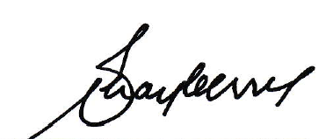

MICHAEL MAYBERRY CSM, MBE
Managing Partner

Contact Details of DFK Mayberry’s Senior Management Team
Michael Mayberry | Sean McNeill | Greg Berry | Warwick Downs
+675 320 1988 | +675 320 1988 | +675 7212 5985 | +675 320 1988
mjm@dfk.com.pg | smcneill@dfk.com.pg | gberry@dfk.com.pg | wdowns@dfk.com.pg

